SPREADSHEETS

Name:

1. Complete the paragraph below by using each word in the table once only.

|  |  |  |  |  |
| --- | --- | --- | --- | --- |
| REFERENCE | RECALCULATED | FORMULAS | DIVIDE | COLUMNS |
| CALCULATIONS | GRID | PROGRAM | SPREADSHEET | ROW |

A spreadsheet is a ___________ which makes it easy for you to work with numbers. It consists of a page made up from _______________ and rows which are arranged into a _______. You can identify every single cell on a spreadsheet by its unique cell _________________, made up from the _____ number and column letter, for example A6, E14, N45. Numbers, text or _____________ can be entered into each cell. Formulas allow you to perform ________________ on the numbers in your spreadsheet. You can add, subtract, multiply and ___________ numbers by using formulas. Using formulas is a very good idea, because it means that once your spreadsheet is set up, any changes you make to one area are automatically _______________throughout the ____________________.

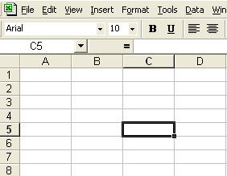

# 2. Label the different parts of this spreadsheet

|  |  |
| --- | --- |
| CELL | ACTIVE CELL |
| TOOLBAR | MENU |
| ROW | COLUMN |

How many rows are shown on this spreadsheet? ………………………………………..

How many columns are shown on this spreadsheet? ..…………………………………

What is the cell reference of the active cell? ………………………………………………

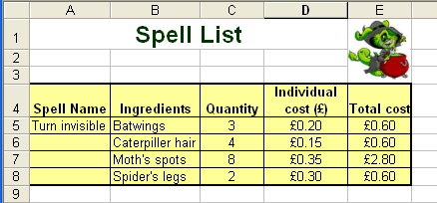

1. Give a cell reference which contains a label

………………………………………………………………………………………………………………

2. Which column letter contains the individual cost of ingredients?

………………………………………………………………………………………………………………

3. Which row number contains the spell name?

………………………………………………………………………………………………………………

4. Which cell reference contains the title ‘ingredients’ ?

………………………………………………………………………………………………………………

5. Which cell reference contains the quantity of Moth’s spots needed?

………………………………………………………………………………………………………………

6. Give a cell reference which contains a value

………………………………………………………………………………………………………………

7. Give a cell reference which contains a formula

………………………………………………………………………………………………………………

8. Write the formula used to work out the total cost of catterpillar hair required.

………………………………………………………………………………………………………………

9.The individual cost of Batswings has gone up from £0.20 to £0.25. Which two cells will change as a result of this price increase?

**Total Marks:**

/29

……………………………………………………………………………